In Loving Memory
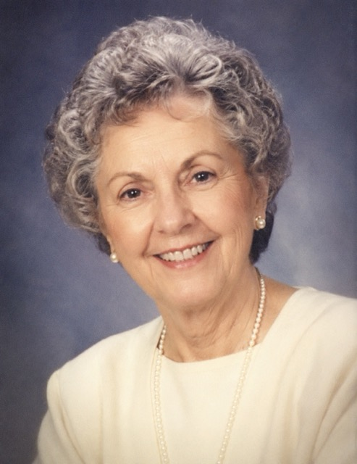
Dorothy Jean Ashby
Dorothy "Dot" Jean Ashby, 78, of Charleston, South Carolina, passed away peacefully on May 18, 2026, with her family near.
Born June 17, 1947, in Savannah, Georgia, to Frank and Helen Carter, Dot trained as a schoolteacher at Georgia Southern and taught third grade for twenty-eight years, where hundreds of children learned to read at her side.
She married Robert Ashby in 1969, and they shared fifty-six years together in the same Charleston neighborhood where they raised their family.
Dot was a devoted member of Grace Baptist Church and rarely missed a Wednesday choir practice. She is remembered for her lemon cake, her wide front porch, and the warmth she offered everyone who passed through her door.
She is survived by her husband Robert, her children Karen (James) and Stephen, four grandchildren, and her brother Paul. She was preceded in death by her parents and her sister, Margaret.
The family will receive friends on Thursday, May 21, at Carolina Memorial Chapel. A funeral service will follow on Friday, May 22, at Grace Baptist Church, with interment at Magnolia Cemetery.

