Obituary Template
Gray Sidebar, with Grain Illustration

In Loving Memory  Jonathan Miller  December 17, 1948 – November 15, 2023  Jonathan Miller, 74, of Springfield, passed away on November 15, 2023, a loving husband, father, grandfather, and friend. He touched the lives of everyone with his kindness and generosity. He will be deeply missed and fondly remembered by his loved ones and all who had the pleasure of knowing him.  He is survived by his wife Mary, his children Robert and Susan, and his grandchildren Emily, Jack, and Sarah.  A life beautifully lived deserves to be beautifully remembered | 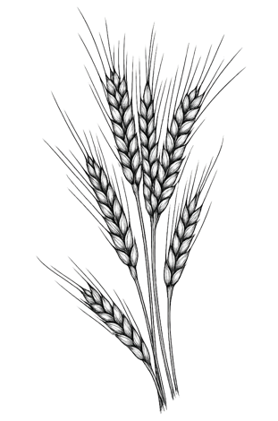

You can find more templates here:

obituary.design
Design a Tasteful Online Obituary in Just a Few Minutes

